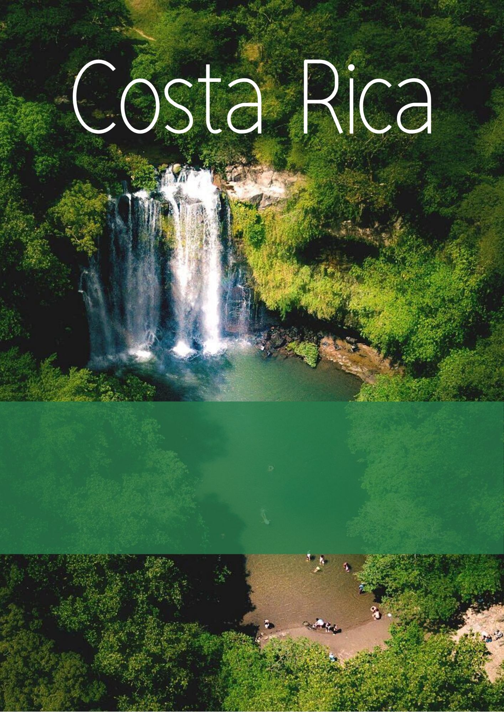

Traveler: Naila Marei X2

Date In: 21 Jun 24
Date Out: 25 Jun 24

DETAILS OF YOUR TRIP
Traveler Name | Naila Marei X2
Arrival date | 21 Jun 24
Departure date | 25 Jun 24
Number of participants | 2 adults
Quotation reference | BKFI104984
DESTINATIONS
Arenal Volcano

DETAILED ITINERARY
Day 1, 18 Jun 24

Private Transfer IN from Airport to Hotel in SJO
Right after you go through immigration and customs one representative will meet you at the Juan Santamaria International Airport (SJO) exit to load the luggage into the vehicle and transfer you to the hotel. The hotel for tonight is close to San Jose city, located 25-15 minutes away from the airport. During the short drive, you will receive a brief introduction to Costa Rica and some recommendations for your trip. The guide will explain your itinerary in detail once you are in the hotel.
Day 4, 21 Jun 24
 | Private Transfer from Siquírres to Arenal
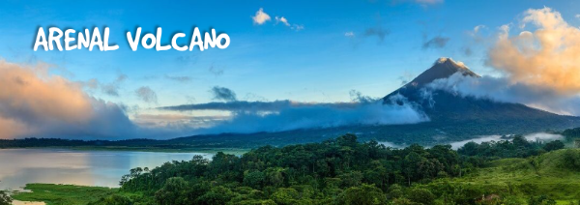
Arenal Volcano
Elevation | 258 m / 845 f | Temperature | 28 C / 82 F
La Fortuna is home to the greater Arenal recreation area, the entire region is paradise on Earth for outdoor adventurers. Volcanic views grace the landscape and heat several geothermal hot springs. A lake and rivers beckon you toward aquatic adventure. Refreshing waterfalls reward you after hikes, offering crisp pools and spectacular views.
Arenal Volcano is one of Costa Rica’s most notable natural features. Standing at 5,437 feet (1,657 meters), this volcano has been resting (i.e. not active) since 2010. However, it is no less majestic to behold, as it’s practically a behemoth against the region’s perfect skies. Rising above the rainforest that surrounds its base, Arenal Volcano frames the skyline with near-perfect symmetry.
Day 5, 22 Jun 24
 | Private: Hanging Bridges, Volcano Walk, La Fortuna Waterfall / Lunch included
Start your day as you walk across the Arenal Hanging Bridges and see the jungle from high above the forest floor. These trails bring you as close as you would ever hope to see the rainforest and its inhabitants, as well as give you access to see stunning views of the rainforest and mountains.
After your adventure on the hanging bridges, you will head to the Arenal Volcano National Park. The trails are generally flat and not very strenuous, perfect for a leisurely and informative guided walk. Enjoy a delicious lunch at this point.
Then, you will finish the day at the stunning La Fortuna Waterfall. When you reach the entrance, you will have time to change into your bathing suit in case you want to cool off in the cool pools that flow from the waterfall. This is sure to be a good workout as there are 500 steps to get to the down to the waterfall, and 300 to get back up! When you reach the bottom, you'll have an opportunity to take lots of pictures and swim in the cool waters of one of the largest and most breathtaking waterfalls in Arenal!
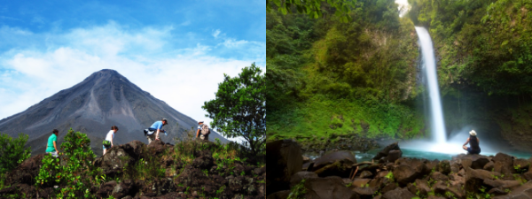

Day 6, 23 Jun 24
 | Private Canyoning in the Lost Canyon / Lunch included
You'll rappel down huge waterfalls, jump into pools, zip down guided rappels, downclimb the canyon walls and river boulders, and hike up through the rainforest.
Start the rappelling-leg of your canyoning journey with the first waterfall referred to as the “Baby”, a small-sized 10 feet waterfall that allows you to ease your way into learning the ropes. You will soon reach what it’s called the “Big Boy”, the second largest waterfall. About half-way through your rappel, you’ll hear the call to “LET GO!” a few moments later you’ll experience your first guided free fall! Finally, you will get the largest Lost Canyon challenge: an exciting 200 feet waterfall rappel.
At the end of this tour, enjoy a delicious typical lunch.
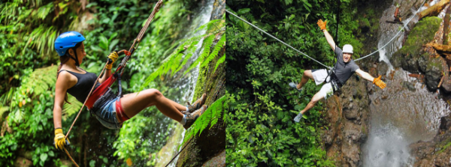

Day 7, 24 Jun 24
Free Day
Enjoy a leisure day in your own way!
If you want to explore more this area, you can acquire an optional tour according to your preferences. Please, do not hesitate to contact your travel expert.
Day 8, 25 Jun 24
 | Private Transfer from Arenal to San Jose
PRICE
Price per person |  | $ 871.00
Total Price |  | $ 1,742.00
General Details of the Price
Prices are per person and in U.S. dollars.
These rates apply for traveling from 18 Jun 24 to 25 Jun 24.
Valid quotation for 2 adults. If the final number of participants change, a new price will be provided.
Rates are subject to change without notice.
INCLUSIONS
TRANSPORTATION & GUIDE SERVICES:
Private Transfer IN from Airport to Hotel in SJO
Private Transfer from Siquírres to Arenal
Private Transfer from Arenal to San Jose
ACTIVITIES & MEALS:
Private: Hanging Bridges, Volcano Walk, La Fortuna Waterfall (Lunch included)
Private Canyoning in the Lost Canyon (Lunch included) in Arenal Volcano
OTHER:
VAT
24/7 professional logistics support during your trip in Costa Rica.
EXCLUSIONS
Optional tours
Departure taxes ($29 per person)
Meals not mentioned in the itinerary
Airfare
Tips
International Travel Insurance
COVID-19 test

